No Ordinary Sun by Hone Tuwhare

Tree let your arms fall:
raise them not sharply in supplication
to the bright enhaloed cloud.
Let your arms lack toughness and
resiliance for this is no mere axe
to blunt nor fire to smother.

Your sap shall not rise again
to the moons pull.
No more incline a deferential head
to the wind's talk, or stir
to the tickle of coursing rain.

Your former shaginess shall not be
wreathed with the delightful flight
of birds nor shield
nor cool the adour of unheeding
lovers from the monstrous sun.

Tree let your naked arms fall
nor extend vain entreaties to the radiant ball.
This is no gallant monsoon's flash,
no dashing trade wind's blast.
The fading green of your magic
emanations shall not make pure again
these polluted skies . . . for this
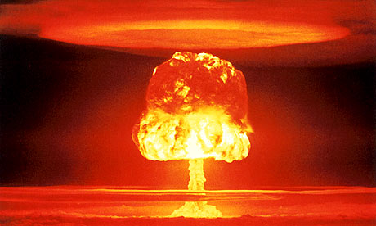
is no ordinary sun.

O tree
in the shadowless mountains
the white plains and
the drab sea floor
your end at last is written

